**Lab 3 Introduction to   
Active Directory and Account Management**

**Lab Assessment 1 Requirements:**

You are given time **until Friday 11:30pm** to complete Lab 03 on **a provided platform independently** without assistance from other people including your Lab Tutor and classmates:

1. Rename this word document as **Lab_Assessment_1_YourName_YourID.docx** where YourName is your real name and YourID is your VU Student ID with s.
2. In this lab assessment, you are required to **capture 15 screens** **(with figure captions) and answer 5 questions**. **All screen shots must show date and time from task bar**. Each is worth 5 points and make up a total of 100 points.
3. Capture the required screenshots and insert them underneath their step instructions. Then save to your file. Marks will be subject to quality of screenshots and figure captions.
4. Upon completion, upload the following **two files** via dropbox on VU Collaborate:
   1. **CoES Assignment Cover Sheet** and
   2. **Lab_Assessment_1_YourName_YourID.docx**

**Late Submission Penalty**

* 1-2 days – 10 points each day
* 3-6 days – 20 points each day
* After 6 days – **0** (**zero**) mark

**Deduction**

* Missing Cover Sheet – 5 points
* Wrong file name – 5 points
* Combined cover sheet file with Lab Assessment file – 5 points
* Missing figure numbers (step numbers) – 5 points
* Missing figure captions – 5 points
* Captured screens without task bar – up to 50 points

**Task 3 – Activity**

**Activity 3-1: Installing DNS Server**

**Objective**: Install DNS Server.

**Description**: In this activity, you learn how to install the DNS Server.

**Requirements**: Take screenshots for **steps 1.0, 1.8 and 1.11**.

**1.0** Open **PowerShel**l prompt, type: **date; ipconfig** (two commands in one line) as below. Press **Enter**.

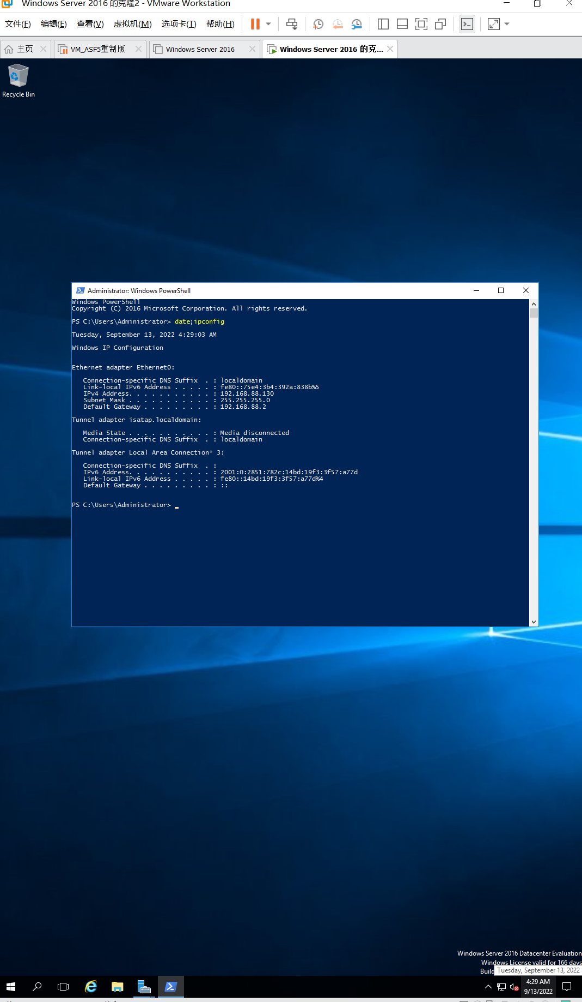

Figure 1.0 Windows Server 2016 Info 1 **Capture your screen, replace the above and save to your file.**

* 1. Open Server Manager, if it is not already open.

1.2 Ensure that Dashboard is selected in the left pane.

1.3 In the right pane, click Add roles and features.

1.4 If you see the Before you begin window, click Next.

1.5 In the Select installation type window, ensure that Role-based or feature-based installation is selected. Click Next.

1.6 Be sure your server is selected in the Select destination server window. Click Next.

1.7 Click the box for DNS Server.

**1.8** In the Add Roles and Features Wizard dialog box, notice the tools to be installed with the Active Directory installation. Click Add Features.

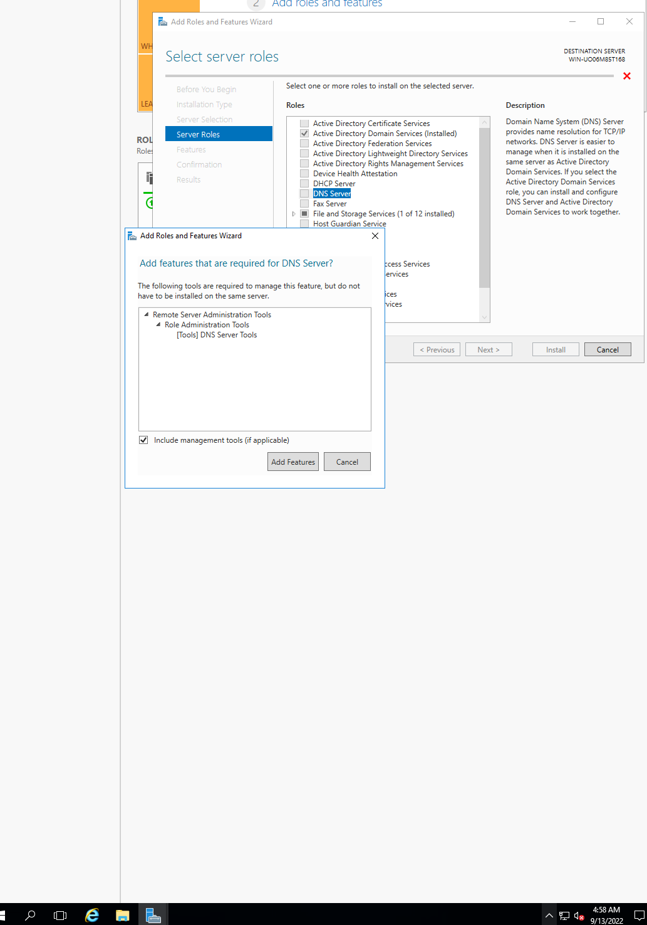

Figure 2.0 I choose DNS

1.9 If warning comes out, ignore it. Click Continue. Make sure DNS Server box is checked. Click Next.

1.10 In Select Features window, click Next. In DNS server window, click Next.

**1.11** In Confirmation window, click Install. Then wait for the installation complete.

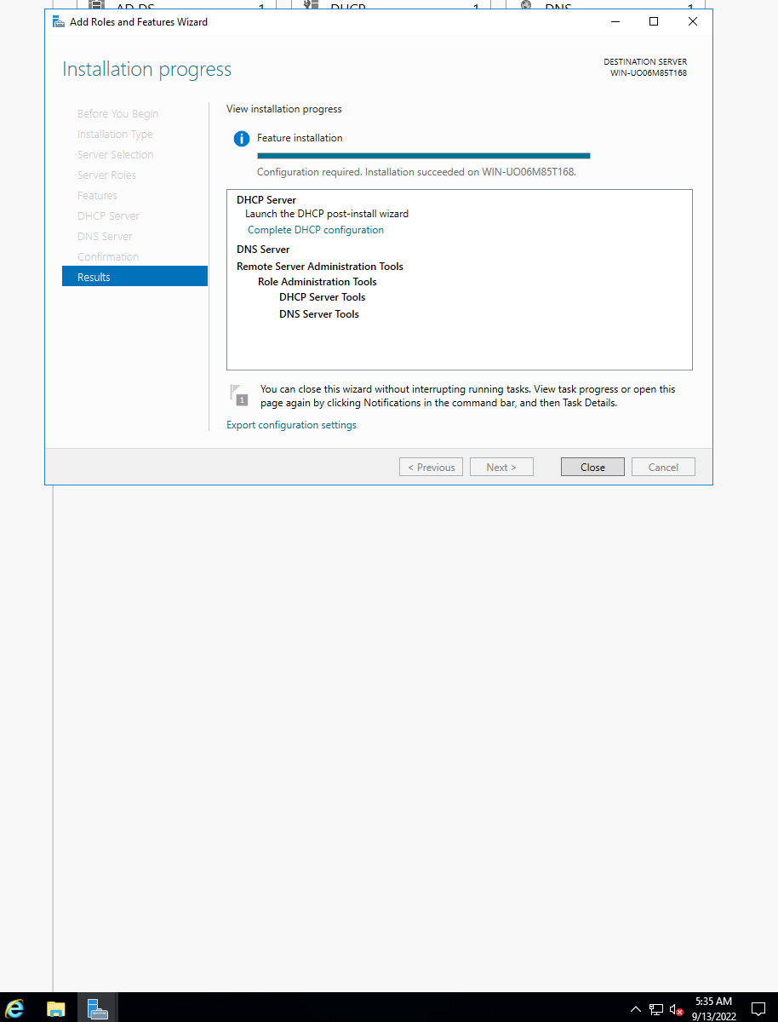

Figure 3.0 I have installed it

**Activity 3-2: Installing Active Directory**

**Objective**: Install Active Directory.

**Description**: To make a Windows Server 2016 server a domain controller, you must install the Active Directory Domain Services role. In this activity, you learn how to install the role. You’ll need to sign in to Windows Server 2016 as Administrator, and should set up a DNS server on your network based on Activity 3-1. Additionally, make sure that all other programs and windows are closed before you start (because the computer will reboot when you finish the installation).

**Requirements**: Take screenshots on **Steps 2.0, 2.8, 2.15, 2.18, and 2.25**, and complete question on **Steps 2.11 and 2.23**.

**2.0** Open **PowerShell** prompt, type: **date; ipconfig /all** (two commands in one line) as below. Press **Enter**.

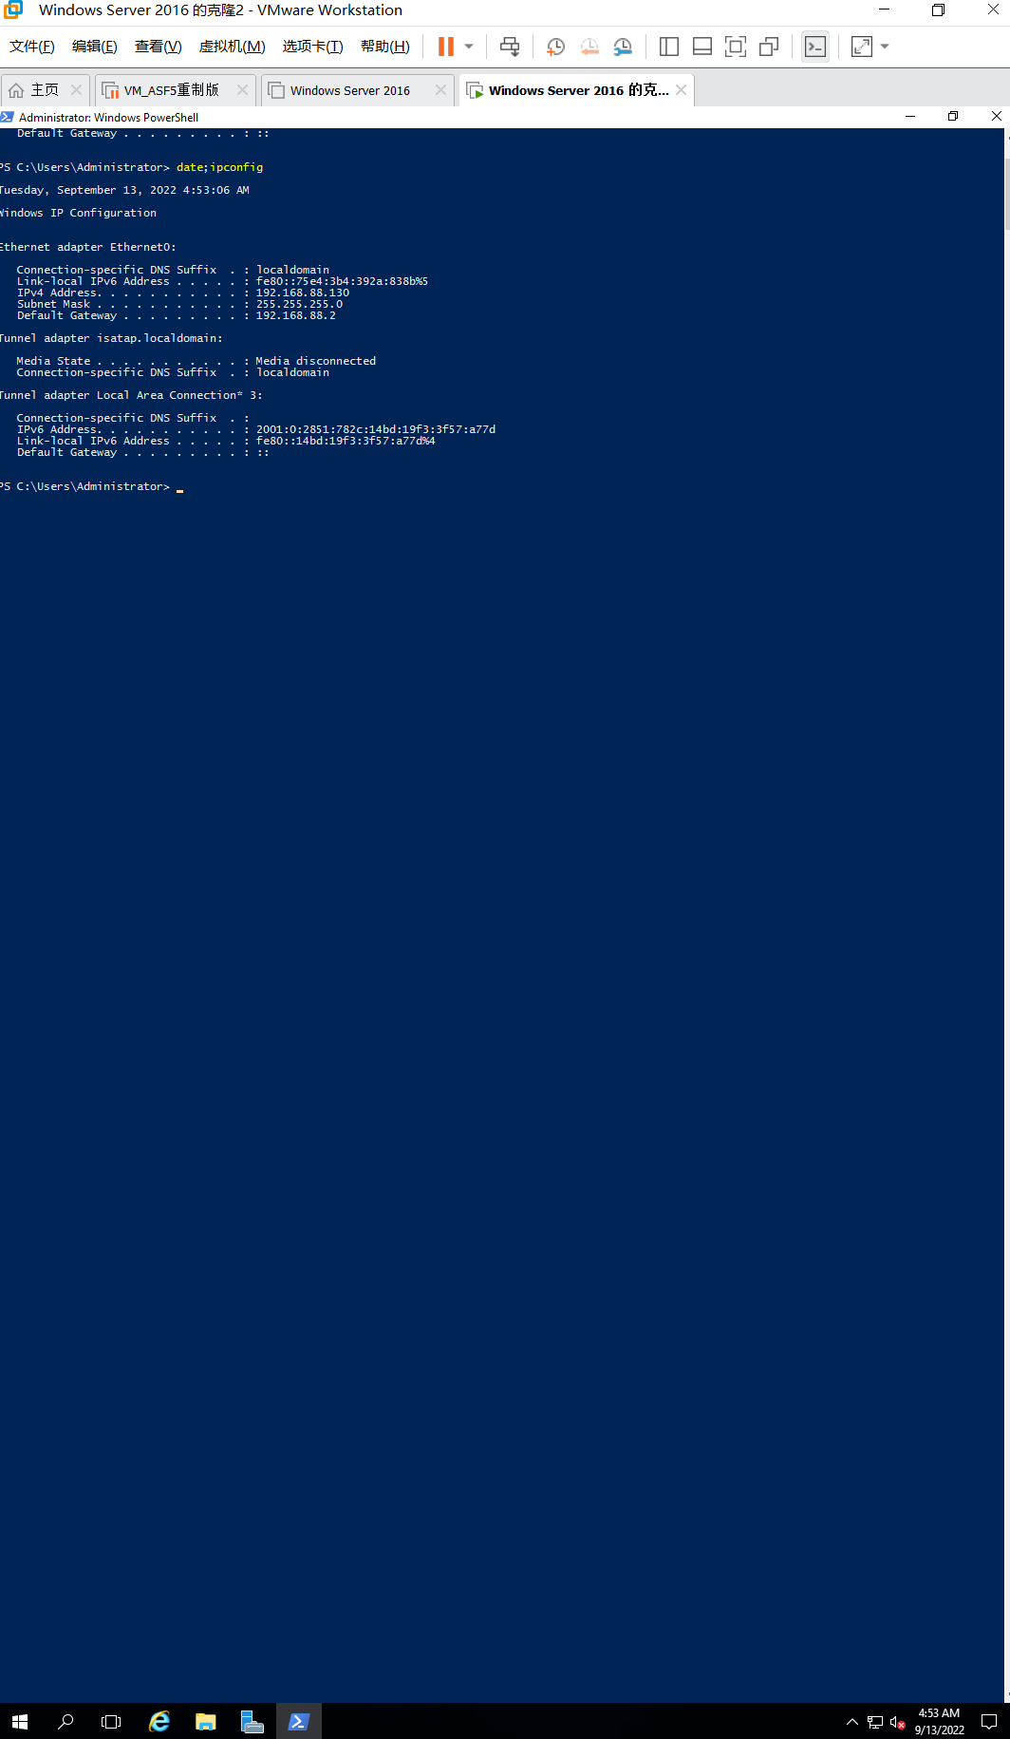

Figure 4.0 Windows Server 2016 Info 2 **Capture your screen, replace the above and save to your file.**

2.1 Open Server Manager, if it is not already open.

2.2 Ensure that Dashboard is selected in the left pane.

2.3 In the right pane, click Add roles and features.

2.4 If you see the Before you begin window, click Next.

2.5 In the Select installation type window, ensure that Role-based or feature-based installation is selected. Click Next.

2.6 Be sure your server is selected in the Select destination server window. Click Next.

2.7 Click the box for Active Directory Domain Services.

**2.8** In the Add Roles and Features Wizard dialog box, notice the tools to be installed with the Active Directory installation. Click Add Features.

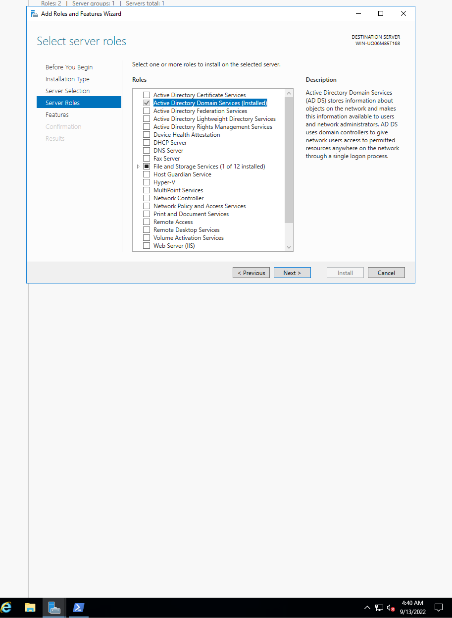

Figure 5.0 Add Active Directory

2.9 Make sure the box for Active Directory Domain Services is checked and click Next.

2.10 Click Next in the Select features window.

**2.11** Read the information about Active Directory Domain Services.

* How many domain controllers are recommended as a minimum for a single domain?

**Two**

2.12 Click Next.

2.13 In the Confirm installation selections window, click Install.

2.14 Wait a few minutes until the installation is completed.

**2.15** Review the information in the Installation progress window, which also shows whether the installation succeeded.

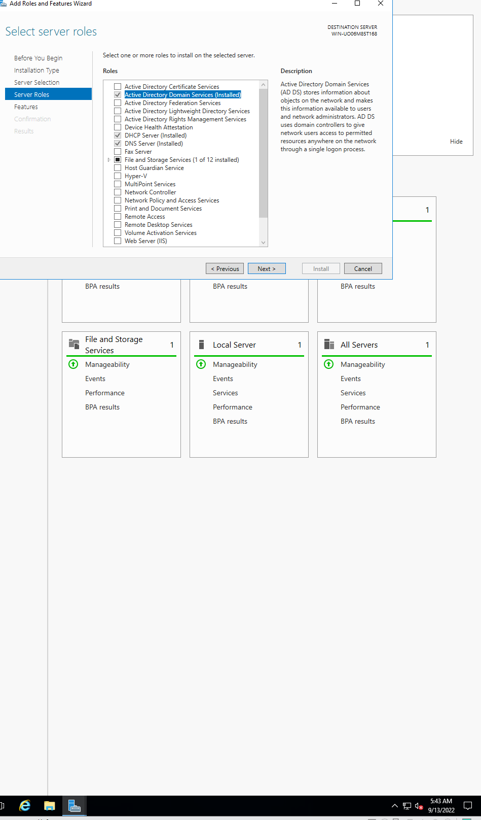

Figure 6.0 I have installed it

2.16 Click Close.

2.17 After the Active Directory Domain Services role is installed, you need to promote the server to a domain controller and configure the AD DS role. Return to Server Manager. Notice there is an exclamation point inside a yellow caution symbol to the left of Manage just under the title bar in Server Manager. Click the exclamation point and then click Promote this server to a domain controller. The Active Directory Domain Services Configuration Wizard opens.

**2.18** Select Add a new forest. Enter a root domain name, **YourID.com** (where **YourID is your VU ID with s**), and click Next.

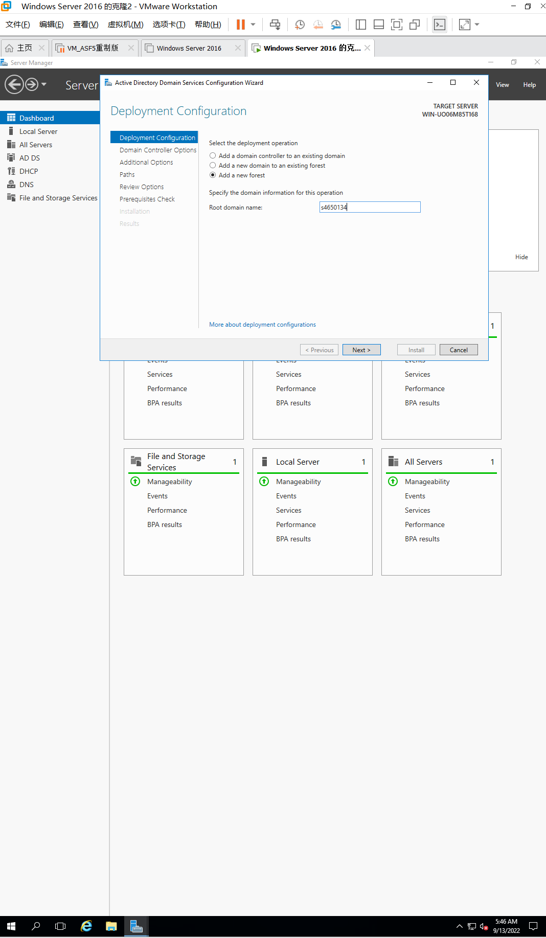

Figure 7.0 Vu ID configuration

2.19 Click the Forest functional level drop-down list arrow. Notice that you can select from different forest functional levels: Windows Server 2008, Windows Server 2008 R2, Windows Server 2012, Windows Server 2012 R2, and Windows Server 2016. For this activity, select Windows Server 2016, unless your instructor specifies otherwise (you learn more about forest functional levels in the section, Forest). Ensure that the Domain functional level box also is selected for Windows Server 2016.

2.20 Enter **NITpassw0rd!** as password for the Directory Services Restore Mode (DSRM), which is used to restore Active Directory, if needed. Confirm the password and click Next.

2.21 If you see a warning that A delegation for this DNS server cannot be created because the authoritative parent zone cannot be found, ignore it firstly. (You learn about configuring DNS in Chapter 8, Managing Windows Server 2016 Network Services.). Click Next.

2.22 In the Additional Options window, verify the NetBIOS name, such as YourID and click Next.

**2.23** In the Paths window leave the database, log files, and SYSVOL folder paths as the defaults.

* Record the location of the database, log files, and SYSVOL folders.

**C:\Windows\NTDS**

**C:\Windows\NTDS**

**C:\Windows\SYSVOL**

2.24 Click Next in the Paths window.

**2.25** Review the selections you have made, click on View Script.

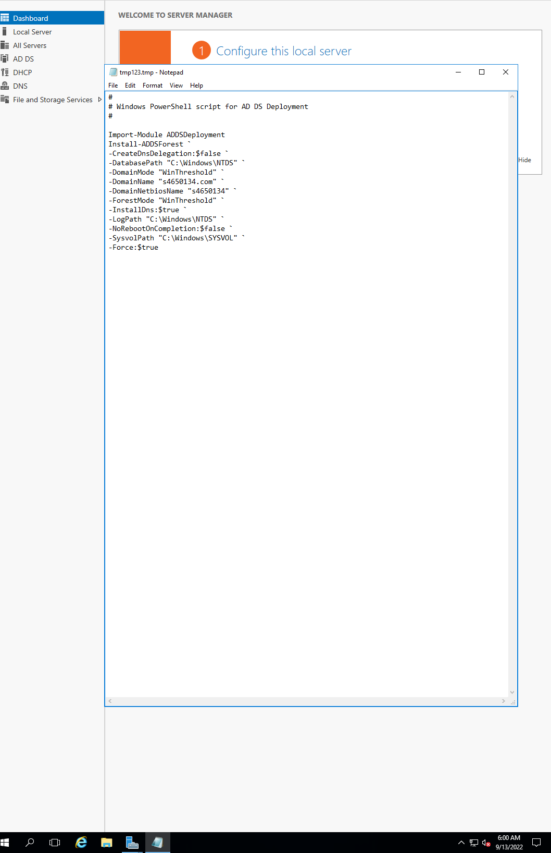

Figure 8.0 View Script

2.26 Click Next in the Review window. The wizard performs a prerequisites check to verify your configuration for what Microsoft calls best practices. For example, if the server is not connected to a network, an error message is shown and the installation process is stopped until this is resolved. If the server does not have a static IP address, the prerequisites check shows a warning. Also, you may see a warning that the delegation for a DNS server cannot be created, if the DNS server installed is not fully configured. If you see warnings, you can continue to install Active Directory and make a note to fix problems associated with the warnings later, if necessary. If you see an error, you cannot continue with the Active Directory Domain Services installation until the error is corrected.

2.27 Click Install. It will take a few minutes for the installation process to complete. The Installation window will again review any warnings.

2.28 Click Close and wait for the computer to reboot.

2.29 Sign in after the computer has rebooted.

**Activity 3-3 Manage OUs**

**Objective**: Create an OU and delegate control over it.

**Description**: One advantage of an OU is that it enables a server administrator to delegate some server management tasks, such as managing user accounts. For example, some organizations prefer to have OUs that reflect the department structure. In this way, user accounts for a particular department are created within an OU, and a department administrator who has authority over an OU can create and manage user accounts for her or his department within the OU. In this activity, you learn how to create an OU and delegate authority for account management within that OU.

**Requirements**: Take screenshots on **Steps 3.0, 3.3, and 3.16** andanswer questions on **Step 3.5**.

**3.0** Open **PowerShell** prompt, type: **date; ipconfig /all** (two commands in one line) as below. Press **Enter**.

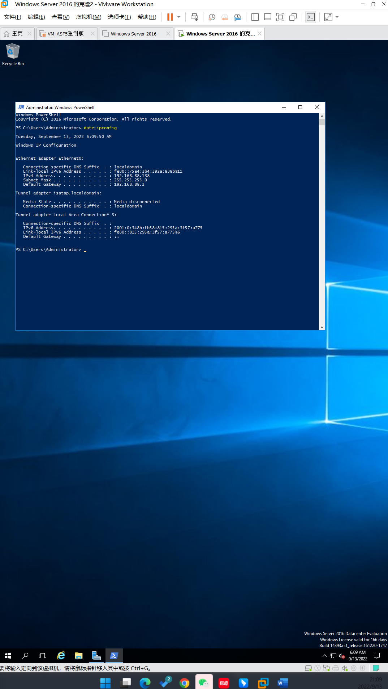

Figure 8.0 Windows Server 2016 Info 8 **Capture your screen, replace the above and save to your file.**

3.1 In Server Manager, click Tools, and click Active Directory Users and Computers.

3.2 Right-click the top domain in the tree in the left pane, such as YourID.com, point to New, and click Organizational Unit.

**3.3** Enter **NITYourID** where YourID is your seven digits of VU Student ID without **s**. Click OK.

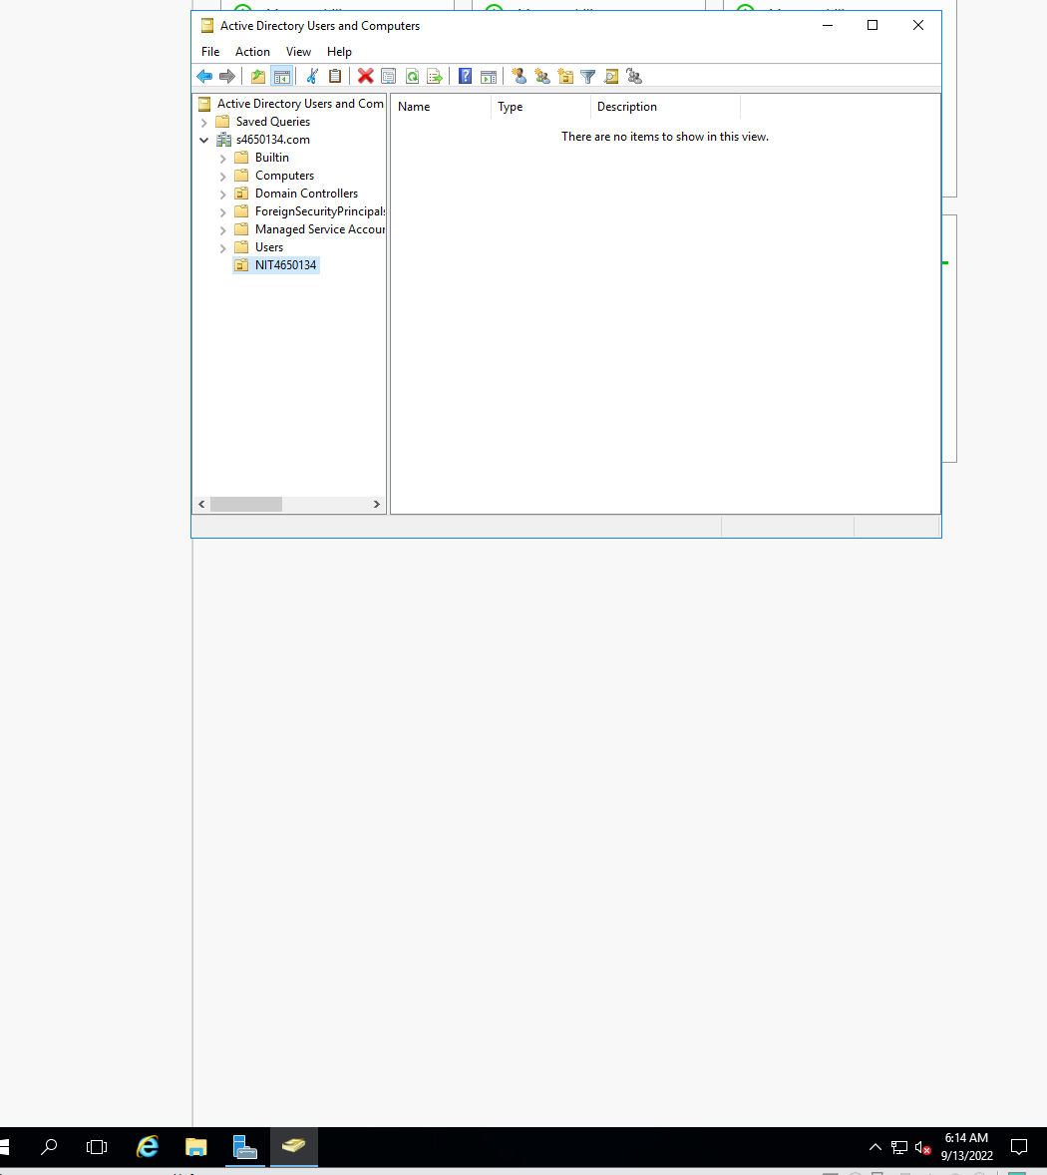

Figure 9.0 Create NIT4650134

3.4 Click the arrow in front of the domain in the left pane so that you can see the OU you created listed under the domain.

**3.5** Right-click the OU, such as **NITYourID**.

* What options are available on the menu?

**Delegate Control**

**Move**

**Find…**

3.6 Click Delegate Control.

3.7 Click Next when the Delegation of Control Wizard starts.

3.8 Click Add.

3.9 Click the Advanced button.

3.10 Click Find Now.

3.11 Because you have not yet defined user accounts, click **Student** for this activity. Notice that names with a single head icon represent accounts and names with a double head icon represent groups of accounts. Click OK.

3.12 Click OK in the Select Users, Computers, or Groups dialog box.

3.13 Click Next in the Delegation of Control Wizard.

3.14Click the box for Create, delete, and manage user accounts.

3.15 Click Next.

**3.16** Review the tasks that you have completed and then click Finish.

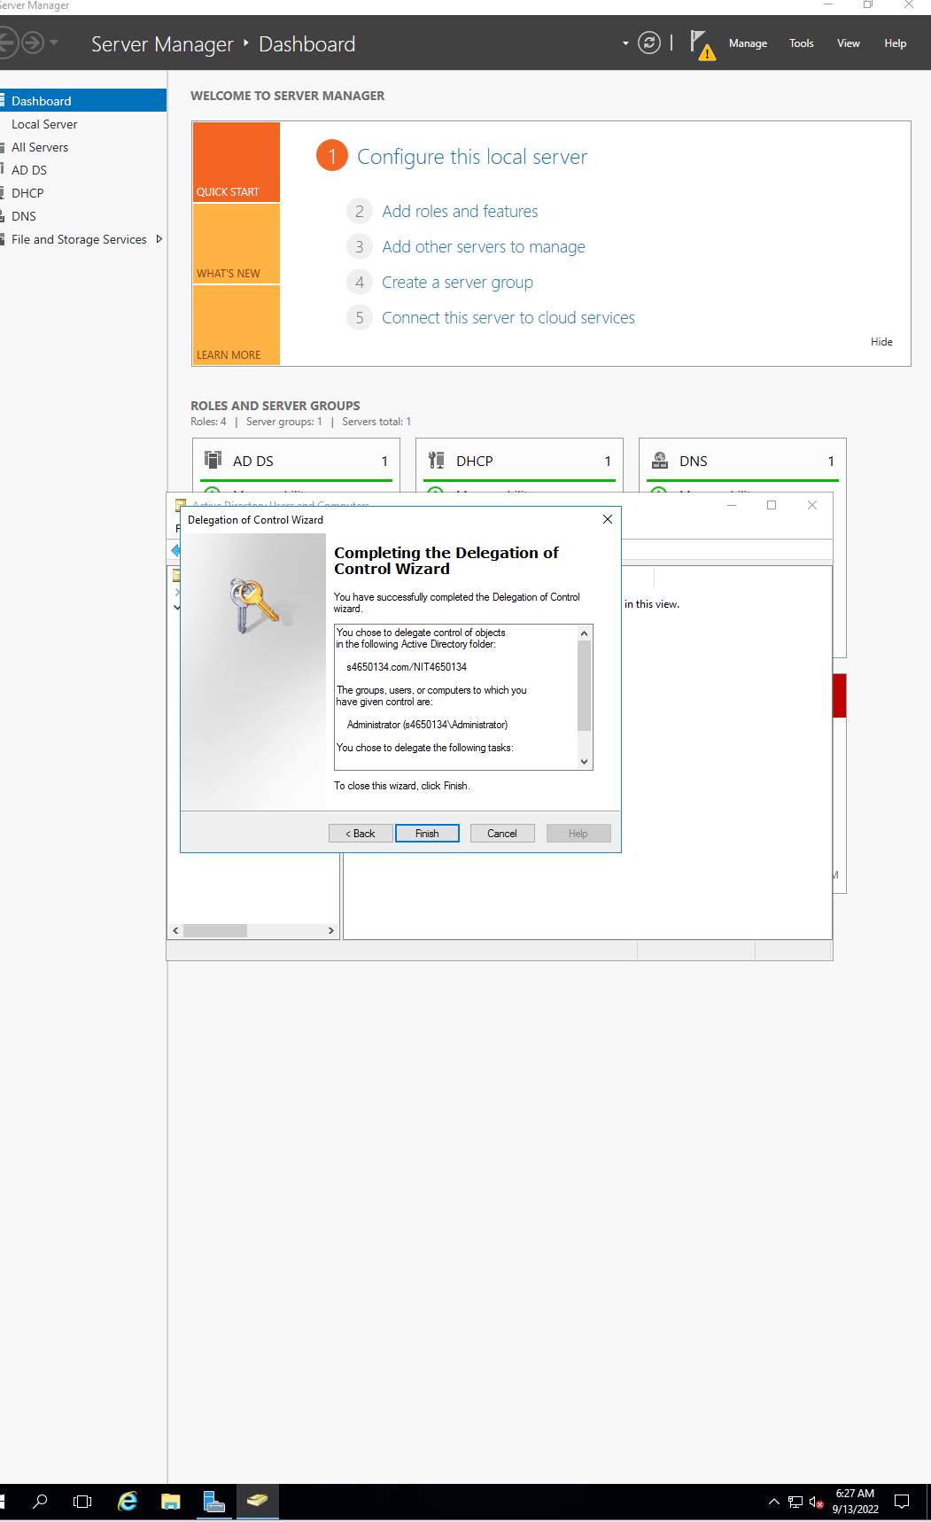

Figure 10.0 The last step

3.17 Close the Active Directory Users and Computers window.

**Activity 3-4: Creating User Accounts in Active Directory**

**Objective**: Learn how to create a user account in Active Directory.

**Description**: Management and access to resources through Active Directory begins through user accounts. In this activity, you learn how to set up a new account.

**Requirements**: Take Screenshots on **Steps 4.0, 4.9, 4.17, 4.22** and answer the questions on **Steps 4.3 and 4.5**

**4.0** Open **PowerShell** prompt, type: **date; ipconfig /all** (two commands in one line) as below. Press **Enter**.

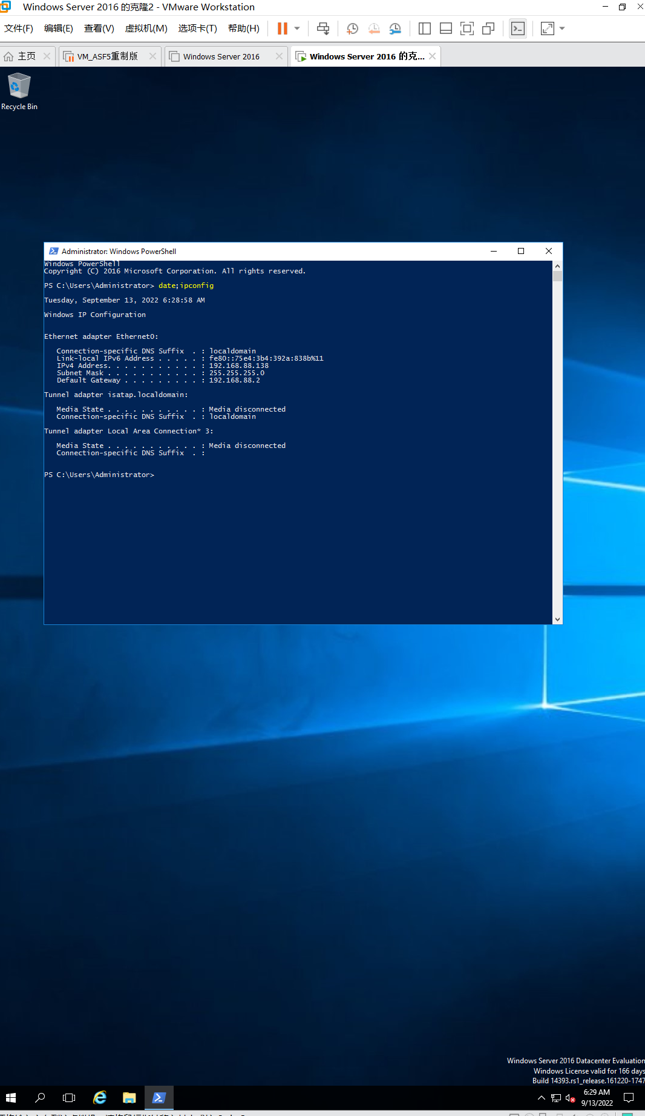

Figure 11.0 Windows Server 2016 Info 4 **Capture your screen, replace the above and save to your file.**

4.1 Right-click Start, click Run, type **mmc** in the Open box, and click OK. Maximize the console window, if necessary. Click the File menu and click Add/Remove Snap-in. Under the Available snap-ins, click Active Directory Users and Computers and click Add. Click OK.

4.2 In the left pane, click the right pointing arrow in front of Active Directory Users and Computers, if necessary, to display the elements under it. Click the right pointing arrow in front of the domain name, such as YourID.com, to display the folders and OUs under it.

**4.3** Click the Users folder in the left pane and then in the middle pane, view the user accounts (with one head icons) and groups (with two head icons) already created.  
• Are any accounts already created? How many groups are shown along with the accounts?

**Yes，about 20**

4.4 Click the Action menu or right-click Users in the left pane, point to New, and click User.

**4.5** Type your first name in the First name box, type your middle initial (no period), and type your last name in the Last name box. Enter YourFirstName.LastName as User login name.

**Email will be set before I write.**  
• Then, which options are automatically completed for you? Which options are not automatically completed?

4.6 Click Next.

4.7 Enter a password and enter the password confirmation. Ensure the box is checked for User must change password at next logon. This option forces users to enter a new password the first time they sign in, so that the account creator will not know their password. The other options include:

* User cannot change password, which means that only the account administrator can change the user’s password
* Password never expires, which is used in situations in which an account must always be accessed, such as when a program accesses an account to run a special process
* Account is disabled, which provides a way to prevent access to an account without deleting it

4.8 Click Next.

**4.9** Verify the information you have entered and click Finish.

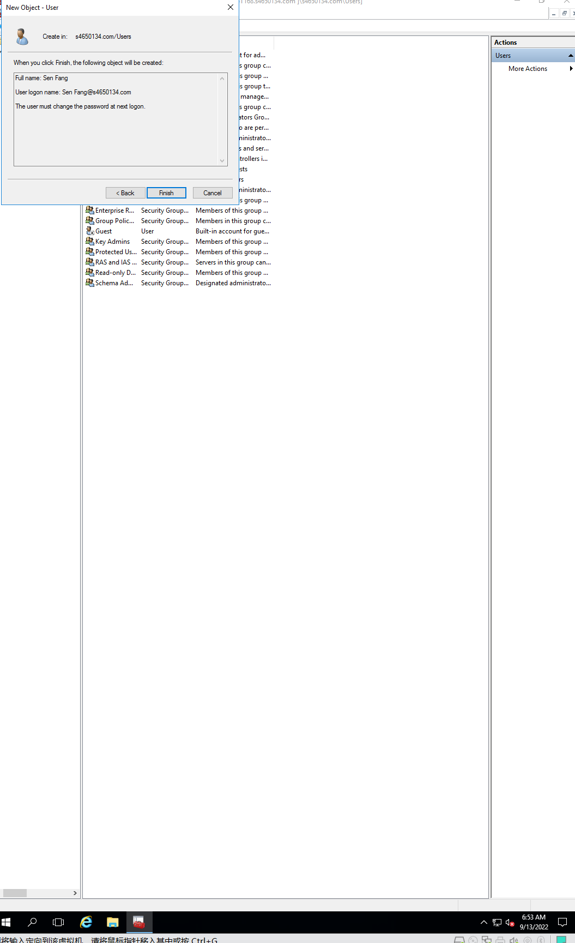

Figure 12.0 finish all steps

4.10 To continue configuring the account, in the middle pane, double-click the account you just created, (alternatively, you can right-click the account and click Properties).

4.11 Notice the tabs that are displayed for the account properties.

4.12 Click the General tab, if it is not already displayed, and enter a description of the account, such as Test account.

4.13 Click the Account tab to view the information you can enter on it.

4.14 Click the tabs you have not yet viewed to find out what information can be configured through each one.

4.15 Click OK.

4.16 To rename the account, right-click it and click Rename. Enter a Your Lecturer name, such as Hao Shi, and then press Enter.

**4.17** When you see the Rename User dialog box, change the First name and the Last name boxes to reflect the new name. Change the User logon name, such as to Hao.Shi. Click OK.

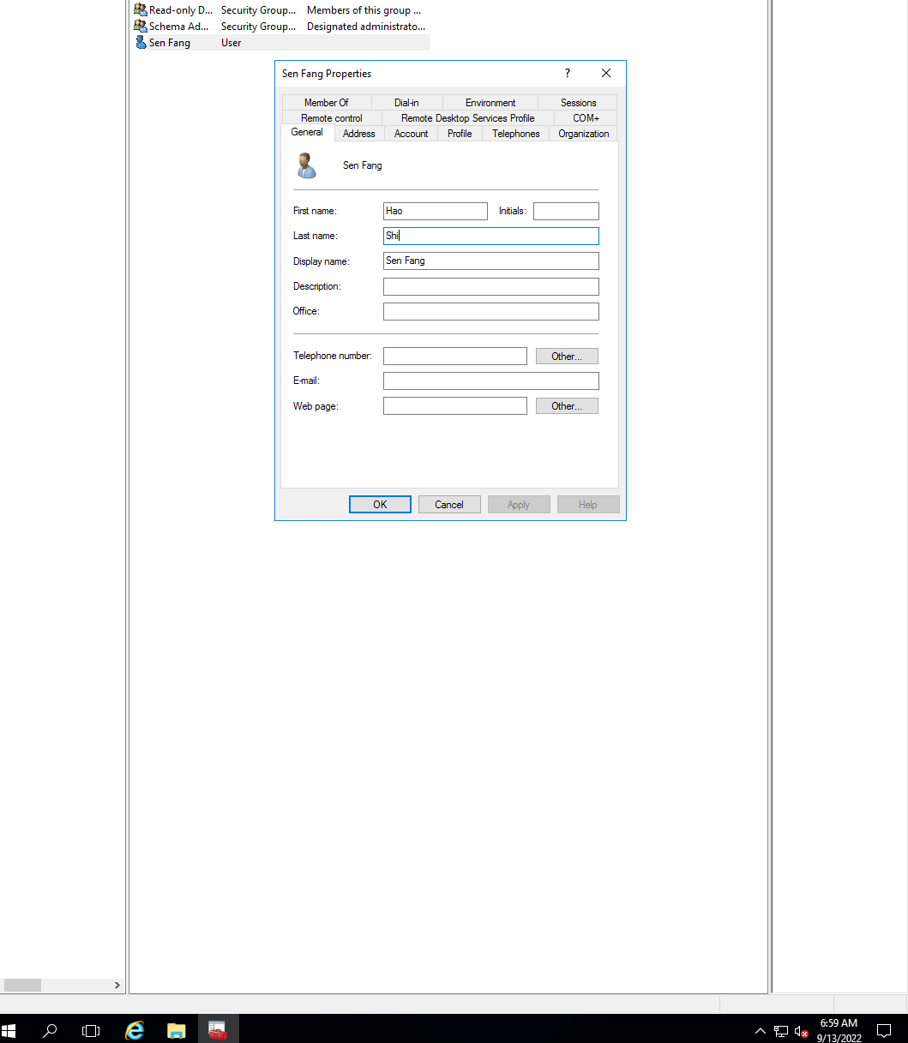

Figure 13.0 finish all steps

4.18 Make sure the account is now listed as Hao Shi in the Users folder.

4.19 Right-click the account you renamed, such as Hao Shi.

4.20 Click Move.

4.21 In the Move dialog box, find the OU that you created in Activity 3-3, such as NITYourID, and click it. Click OK.

**4.22** In the tree of the left pane, click the OU to which you moved the account and verify that the account is moved (see the middle pane).

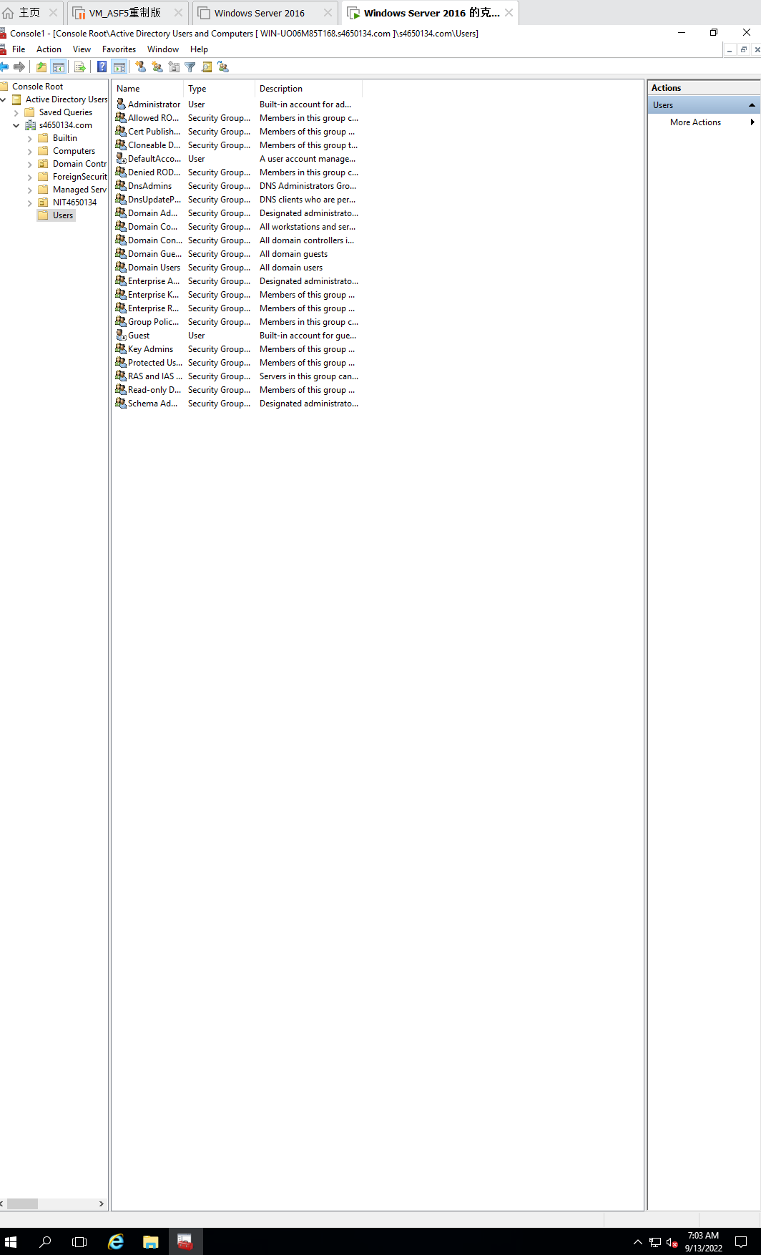

Figure 14.0 move user

**Congratulations! You reach the end of Lab Assessment 1**. Logon VU Collaborate and upload two separated files:

1. **CoES Assignment Cover Sheet**
2. **Lab_Assessment_1_YourName_YourID.docx**

via dropbox.

**Turn off your virtual machine on a provided platform.**